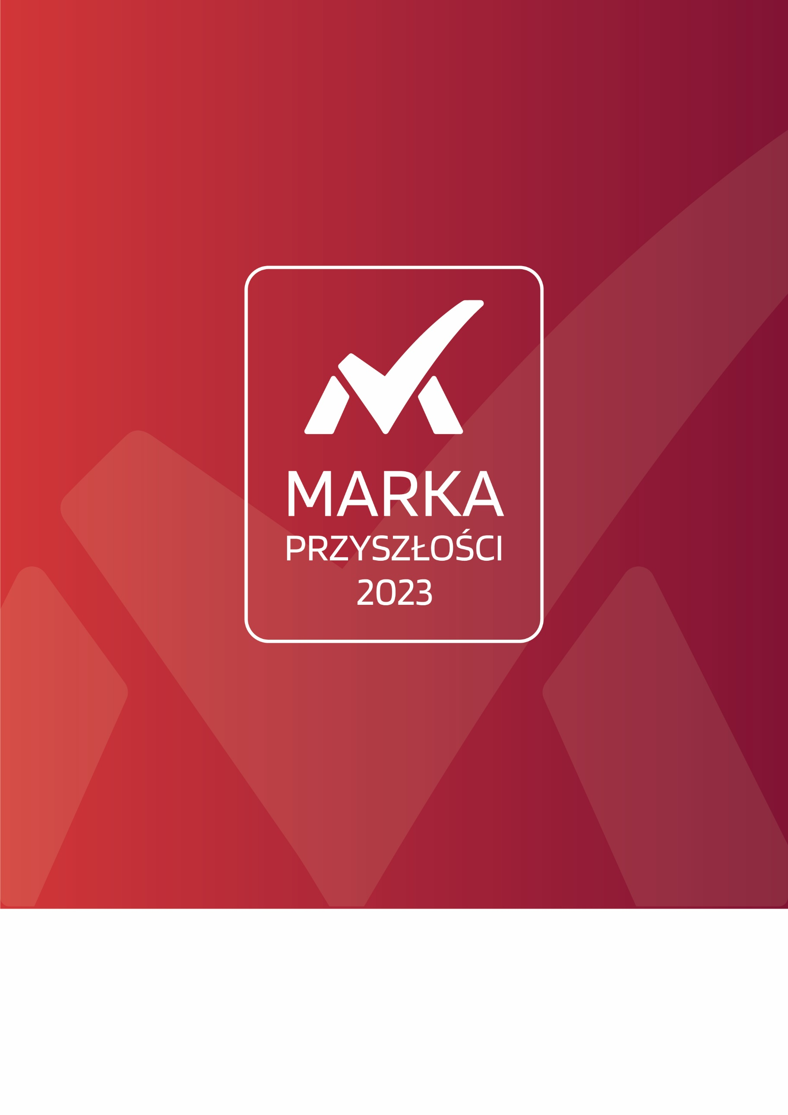
Verification questionnaire
AWARD AND EMBLEM BRAND OF THE FUTURE 2023
The questionnaire is addressed to people responsible for building and strengthening the image of brands participating in the process of selecting the Laureates of the Award and Emblem "Brand of the Future" 2023. The data contained in the questionnaire is used to select the Laureates of the award, and the completed and signed document is necessary for the final decisions of the Organizer of the award.

Behind the success of any brand there are people - people who are responsible for the idea for a product, service, innovative activity, but always also people who take care of good PR, marketing and advertising of the idea entering or functioning in the economic space. We see their activities in the public space - in the media, at events they organize or events they participate in, or in promotional and marketing campaigns. And it is the work of these groups that we recognize under the "Brand of the Future" program - to them we dedicate the award.

The "Brand of the Future" award and emblem is an image-based consumer program aimed at entities representing smartly developing brands communicating on a partnership basis with the customer, the recipient of their solution, a business partner or a resident of the region of operation.

To do so, the nominees and Laureates simultaneously use the most popular means of communication and promotion of their activities - that is, national and prestigious media devoted to socio-economic issues, as well as social media. The purpose of their public relations activities is to highlight the importance of the benefits that the brand offers through its own smart development, as well as to listen to the voice of the recipient of their activities. These activities always go hand in hand.

Smart development - understood as the introduction of innovations, combined with respect for the environment, and at the same time with active promotion of its activities and communication with the public lies at the very basis of the activities of the Center for Smart Development - the organizer of the award, as well as the 8th edition of the "congress of projects of the future", or "Forum for Smart Development", and the publisher of the thematic section "Rzecz o Innowacjach i Inwestycjach".

The organizer of the award is guided by the idea that any brand that wants to achieve success, increase recognition, trust, build market position, eventually stay on top, and be associated with innovation, development, the future - communicate clearly its achievements, and listen to the needs, motivations and desires of its audience. The brand of the future involves the audience of its products or services in the process of building and development, as well as arouses strong, positive emotions through thoughtful PR activities.

W związku z powyższą ideą, ankieta weryfikacyjna Nagrody i Godła „Marka Przyszłości” ukierunkowana jest przede wszystkimi na analizę działań promocyjnych prowadzonych przez Uczestnika programu – Nominowanego lub zgłaszającego swoją kandydaturę samodzielnie – w ogólnopolskich mediach drukowanych, elektronicznych, podczas wydarzeń gospodarczych dedykowanych inteligentnemu rozwojowi gospodarczemu, z szczególnym uwzględnieniem propozycji medialnych i konferencyjnych przygotowanych przez Organizatora programu, a dedykowanych ściśle wzmacnianiu wizerunku marki w społeczeństwie.

In connection with the above idea, the verification questionnaire for the "Brand of the Future" Award and Emblem is aimed primarily at analyzing the promotional activities carried out by the Program Participant - Nominated or submitting its candidacy on its own - in the nationwide print media, electronic media, during economic events dedicated to smart economic development, with particular emphasis on media and conference proposals prepared by the Program Organizer, and dedicated strictly to strengthening the brand image in society.

"Brand of the Future" counts among the Awards of the Intelligent Development Forum (www.irforum.pl), where it will be presented to the Laureates during the 8th edition of the FIR, as part of the Gala. The decision to grant the award is made within 30 days of receipt by the Organizer of a properly completed and signed questionnaire. Laureates of the "Brand of the Future" from the decision may use the logotype of the award for all promotional, marketing and advertising purposes.

The Organizer reserves the right to exclude from the further process of selecting the Laureates and awarding the emblem "Brand of the Future" those entities that declare in the questionnaire that they do not or will not carry out within the next 12 months promotional activities within the framework of communication with the public through the nationwide media. This has to do with the regulations of the Award, based on its idea and objectives.

I. Identification Data of the Owner/Brand Manager

1. Full name: |  | Kliknij tutaj, aby wprowadzić tekst.
2. Legal form: |  | Kliknij tutaj, aby wprowadzić tekst.
3. Date of commencement of operations: |  | Kliknij tutaj, aby wprowadzić tekst.
4. Tax Identification Number: |  | Kliknij tutaj, aby wprowadzić tekst.
5. REGON number: |  | Kliknij tutaj, aby wprowadzić tekst.
6. Address:
City: | Kliknij tutaj, aby wprowadzić tekst. |  |  | Street: | Kliknij tutaj, aby wprowadzić tekst.
Premises number: | Kliknij tutaj, aby wprowadzić tekst. |  |  | Province: | Kliknij tutaj, aby wprowadzić tekst.
7. Contact information
Phone number: | Kliknij tutaj, aby wprowadzić tekst. |  |  | Fax number: | Kliknij tutaj, aby wprowadzić tekst.
www address: | Kliknij tutaj, aby wprowadzić tekst. |  |  | E-mail: | Kliknij tutaj, aby wprowadzić tekst.
8. Managing person
Full name: | Kliknij tutaj, aby wprowadzić tekst. |  |  | Position: | Kliknij tutaj, aby wprowadzić tekst.
Phone number: | Kliknij tutaj, aby wprowadzić tekst. |  |  | E-mail: | Kliknij tutaj, aby wprowadzić tekst.
9. Contact person for participation in the program
Full name: | Kliknij tutaj, aby wprowadzić tekst. |  |  | Position: | Kliknij tutaj, aby wprowadzić tekst.
Phone number: | Kliknij tutaj, aby wprowadzić tekst. |  |  | E-mail: | Kliknij tutaj, aby wprowadzić tekst.
10. Number of employees: |  |  | Kliknij tutaj, aby wprowadzić tekst.

II. Data on the operating Brand in the market

1. Brand category
☐ | Product
☐ | Service
☐ | Organization
☐ | Location
☐ | Event
☐ | Investment
2. Genesis of the creation and description of the brand's operation
Kliknij tutaj, aby wprowadzić tekst.
3. Benefits the Brand brings to society/economy
Kliknij tutaj, aby wprowadzić tekst.
4. Promotion of the Brand in the national media
(description of the most important activities undertaken in the last 12 months)
Kliknij tutaj, aby wprowadzić tekst.
5. Brand communication in social media
(description of the most important activities undertaken in the last 12 months)
Kliknij tutaj, aby wprowadzić tekst.
6. Promotion of the Brand through the proposals of the Prize Organizer
☐ | The Thing About Innovation
☐ | Smart Development Forum
☐ | None
Justification for the decision
Kliknij tutaj, aby wprowadzić tekst.

II. Data on the operating Brand in the market

1. Brand category
☐ | Product
☐ | Service
☐ | Organization
☐ | Location
☐ | Event
☐ | Investment
2. Genesis of the creation and description of the brand's operation
Kliknij tutaj, aby wprowadzić tekst.
3. Benefits the Brand brings to society/economy
Kliknij tutaj, aby wprowadzić tekst.
4. Promotion of the Brand in the national media
(description of the most important activities undertaken in the last 12 months)
Kliknij tutaj, aby wprowadzić tekst.
5. Brand communication in social media
(description of the most important activities undertaken in the last 12 months)
Kliknij tutaj, aby wprowadzić tekst.
6. Promotion of the Brand through the proposals of the Prize Organizer
☐ | The Thing About Innovation
☐ | Smart Development Forum
☐ | None
Justification for the decision
Kliknij tutaj, aby wprowadzić tekst.

II. Data on the operating Brand in the market

1. Brand category
☐ | Product
☐ | Service
☐ | Organization
☐ | Location
☐ | Event
☐ | Investment
2. Genesis of the creation and description of the brand's operation
Kliknij tutaj, aby wprowadzić tekst.
3. Benefits the Brand brings to society/economy
Kliknij tutaj, aby wprowadzić tekst.
4. Promotion of the Brand in the national media
(description of the most important activities undertaken in the last 12 months)
Kliknij tutaj, aby wprowadzić tekst.
5. Brand communication in social media
(description of the most important activities undertaken in the last 12 months)
Kliknij tutaj, aby wprowadzić tekst.
6. Promotion of the Brand through the proposals of the Prize Organizer
☐ | The Thing About Innovation
☐ | Smart Development Forum
☐ | None
Justification for the decision
Kliknij tutaj, aby wprowadzić tekst.

III. Data on the debuting Brand
(Field to be filled in to present the Brand debuting in the next 6 months. Maximum of one brand)

1. Description of the operation of the future Brand
Kliknij tutaj, aby wprowadzić tekst.
2. Benefits the Brand will bring to society/economy
Kliknij tutaj, aby wprowadzić tekst.
3. Promotion of the Brand in the national media
(description of the most important activities currently being undertaken and in the next 6 months)
Kliknij tutaj, aby wprowadzić tekst.
4. Brand communication in social media
(description of the most important activities currently being undertaken in the next 6 months)
Kliknij tutaj, aby wprowadzić tekst.
5. Promotion of the Brand through the proposals of the Prize Organizer
☐ | The Thing About Innovation
☐ | Smart Development Forum
☐ | None
Justification for the decision
Kliknij tutaj, aby wprowadzić tekst.

IV. Strategy for promoting the Brand and communicating with audiences in the future
(description of actions to be taken in the future for smart development of the brands)
1. Description
Kliknij tutaj, aby wprowadzić tekst.

V. Team in charge of PR, communications and advertising for the Brand
(description of the successes of the team responsible for the development of the brands, personnel composition of the team, etc.).
1. Description
Kliknij tutaj, aby wprowadzić tekst.

IV. Statements

Participant Statements:
I declare that the data contained in the participation questionnaire is true.

I agree to collect the information contained in the questionnaire and to store the submitted documents in the place designated by the Program Organizer.

I consent to the processing of the data contained in the questionnaire for the purpose of organizing the Program in accordance with Article 6(1)(a) of the Regulation of the European Parliament and of the Council (EU) 2016/679 of April 27, 2016 on the protection of individuals with regard to the processing of personal data and on the free movement of such data and repealing Directive 95/46/EC (General Data Protection Regulation)."

I declare that I am familiar with the content of the Regulations "Award and Emblem of the Brand of the Future 2023" and agree to its provisions.
City: | Kliknij tutaj, aby wprowadzić tekst.
Date: | Kliknij tutaj, aby wprowadzić datę.
Signature and stamp of the Participant:

